**6th Grade Assignments – Math/ Science**

Minaya

Hello sixth graders! We will be keeping in touch virtually for a few days 😊. Make sure to put down that Tik Tok account and that PlayStation and do some of your work. I have updated some work online aside from the packet given to you; and Yes! all of it is due! The work is not meant to be overwhelming but just enough for you to keep busy and learning as well.

**Down to business**- Make sure you read this page completely-Students are expected to work **daily** on Math and Science Assignments. It is recommended that you spend at least *3 hours daily on the work assigned*.

Students were sent home with a packet with some review work. That packet is expected to be completed and returned back to school, along with any homework assignments given up to Thursday.

Students who have been absent must make every effort to complete all the pages in the math modules.  
**GREEKS**- Complete up to Lesson 17 (Writing Expressions) Page 76.  
**ROMANS**- Complete up to Lesson 9 (Writing Addition and Subtraction Expressions) Page 44.

**SAMPLE PACE Guide**

|  |  |  |
| --- | --- | --- |
| **Day Assignments** | **Math** | **Science** |
| DAY 1 | * Packet (2 pages) * Khan Academy-Expressions | Research- Brain Pop  Google Search |
| DAY 2 | * Packet (2 pages) * Khan Academy-Expressions  Distributive Property | Research- Discovery Education  Google Search |
| DAY 3 | * Complete Packet * **Castle Learning**- 2018 Grade 6 NYS Math Sampler - Session 1 | Research- Planning and collect materials |
| DAY 4 | * Khan Academy- Combine Like Terms * **Castle Learning**- 2018 Grade 6 NYS Math Sampler - Session 2 | Planning- READ the poster outline and Draft poster. |
| DAY 5 | * **Castle Learning**- NYS Grade 6 Math Test Released Questions 2018-05 * Khan Academy- Percent  Ratios and Rates | Draft- check your list and Rubric pencil copy-add all parts |
| DAY 6 | * Finish any MODULES assignment Make sure all pages completed. * Complete any missing assignments in any of the websites. * Sum Dog If done | Final Draft- Go over work  Check spelling and grammar.  Add color and jazz! |

**\*\*\* Online MATH \*\*\***

Moving forward, students are also expected to work on the following instructional material online.

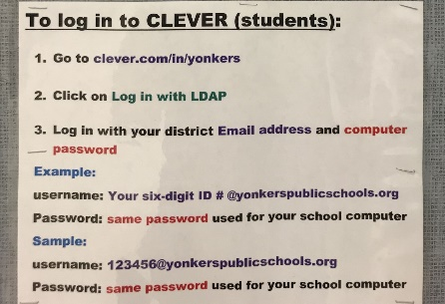

**Castle Learning**- LOG in through the CLEVER website

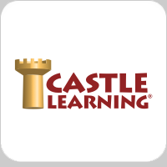 🡪 [www.clever.com/in/yonkers](http://www.clever.com/in/yonkers)

USERNAME: studentID (6 digits) **123456@yonkerspublicschools.org**

PASSWORD: **same password** you use for school computer

You have 3 NYS 2018 Math practice test assigned. Castle learning is a great tool to use; it provides the students immediate feedback on their answers; it also guides the students tips to help find and correct their errors. ALL assigned test will be seen by teacher and graded.

**Khan Academy**- MUST LOG IN outside of Clever

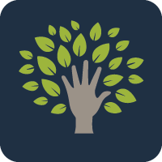🡪 Go directly to [www.Khanacademy.org](http://www.Khanacademy.org)

USERNAME: **firstnamelastname** *check notebook  
 PASSOWRD: **school13**

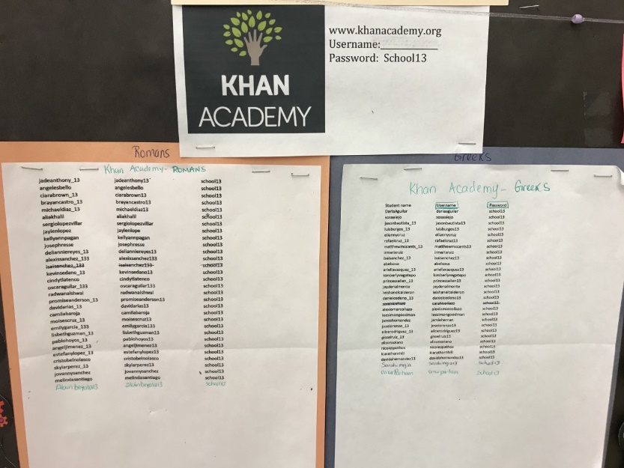10 content skills - Video and Practice work  
It is important for the student to take time to **watch the videos** as it would served as review and homework help. Then complete the practice problems.

Evaluating Expressions  
Equivalent Expressions  
Distributive Property  
Combining Like terms  
Finding Percent  
Ratios and Rates  
Absolute Value  
Coordinate Plane  
Number Line-Ordering Negative Numbers  
Decimal/Fractions Names on the Last page

**SCIENCE- The Rock Cycle**

Students are expected to do some research on the different types of rock and the rock cycle. Use the information online to read, watch videos and look at sample rock cycle and pictures to create your own poster on the Rock Cycle. Students most included all the vocabulary word in the worksheet attached and a definition for each of those words, on their posters.   
Attached is a guide and rubric to help you create your informational posters.  
  
You may use the following website links through clever, to help you start your research.

* Brainpop - <https://www.brainpop.com/search/?keyword=rock+cycle>
* Discovery Education- <https://cleversso.discoveryeducation.com/learn/search?q=rock+cycle>  
  + - Google- Rock Cycle project pictures

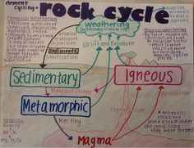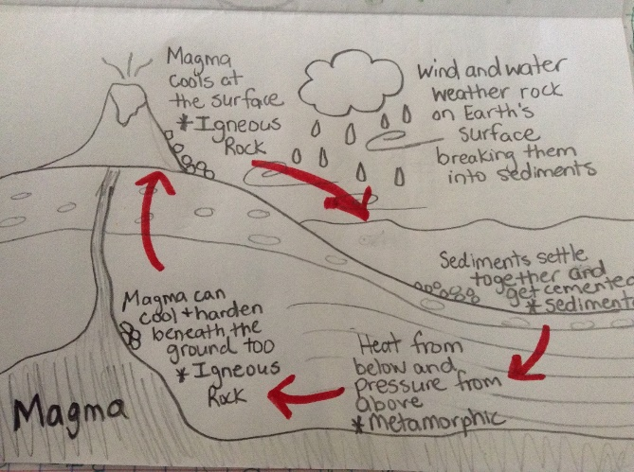

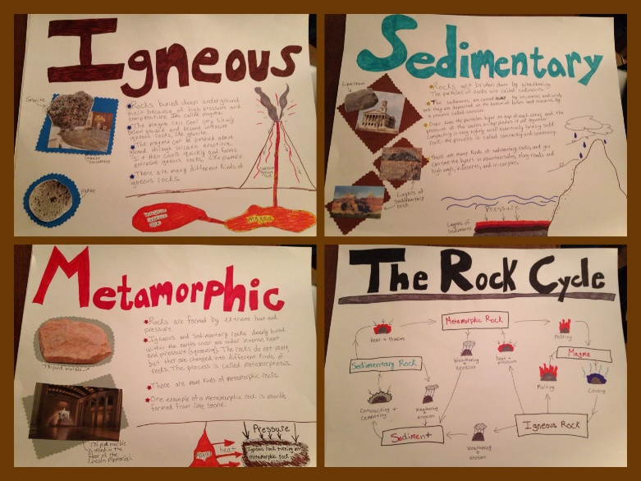

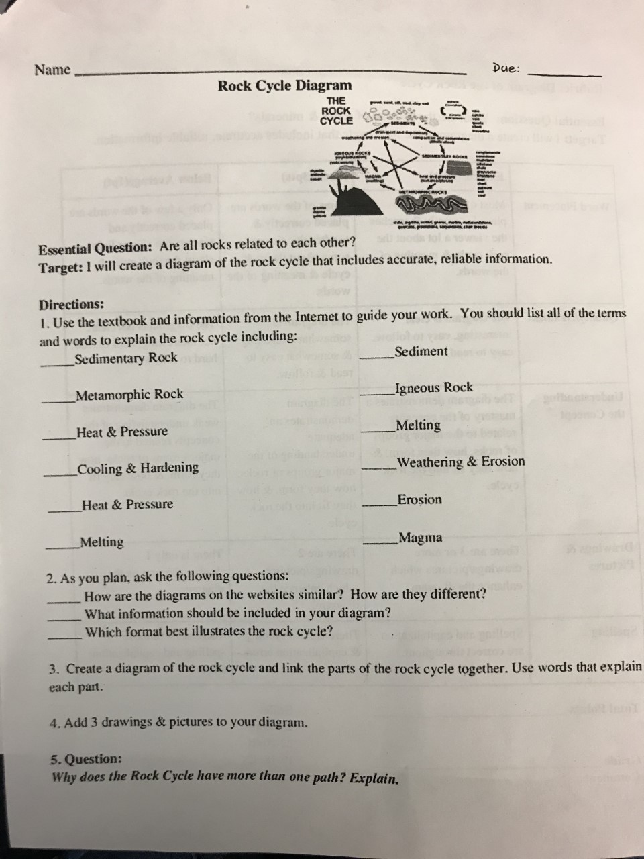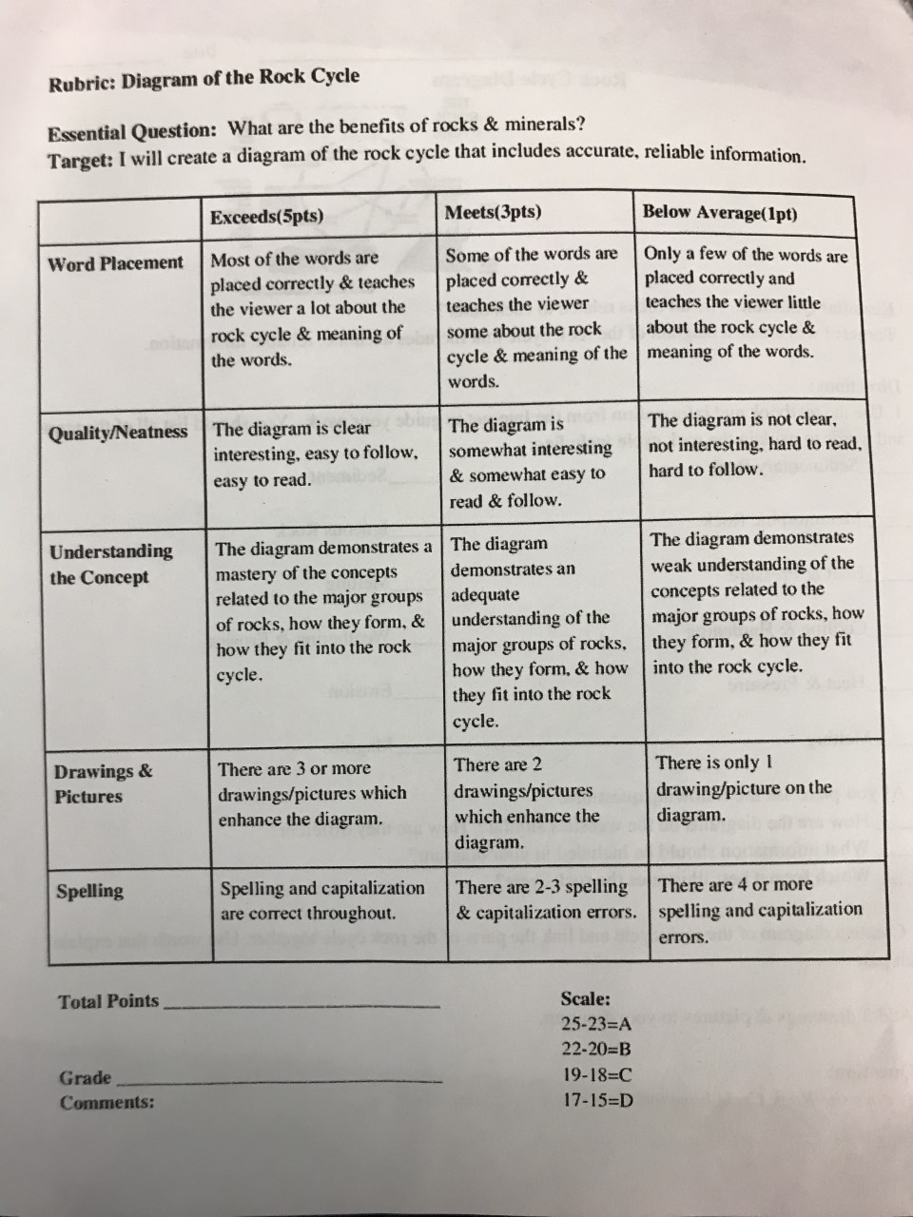

** Please note I will be monitoring students’ log in for each of the websites. Their performance and time spent will also be monitored for each assignment in the different websites.

Please take your time and do the work to the best of your availability. This is meant to help you prepare for the upcoming state test and ensure that your learning continues. **

Have a good week and stay safe. See you all soon! 😊

Khan Academy Username LOG In

